**Final Project Part I**

Alexander Hartschenko

SNHU

IT-230: Software Development with C#.NET

Professor John Wetsch

December 1, 2024

**Final Project Part I**

Screenshot 1.

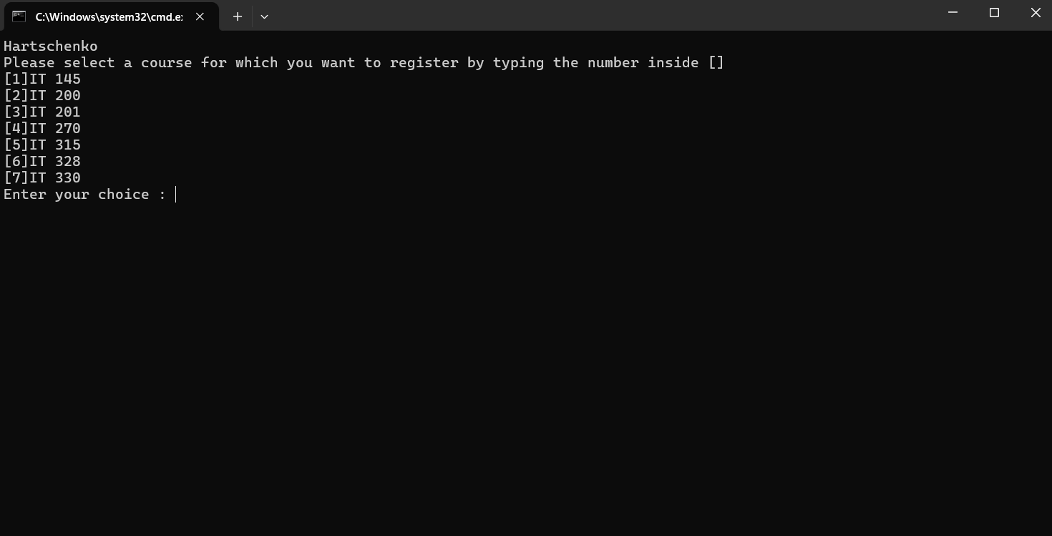

This is the initial screen after running the program. Here, my name is displayed first with the menu and its options below. At the end is the prompt for the user’s answer.

Screenshot 2.

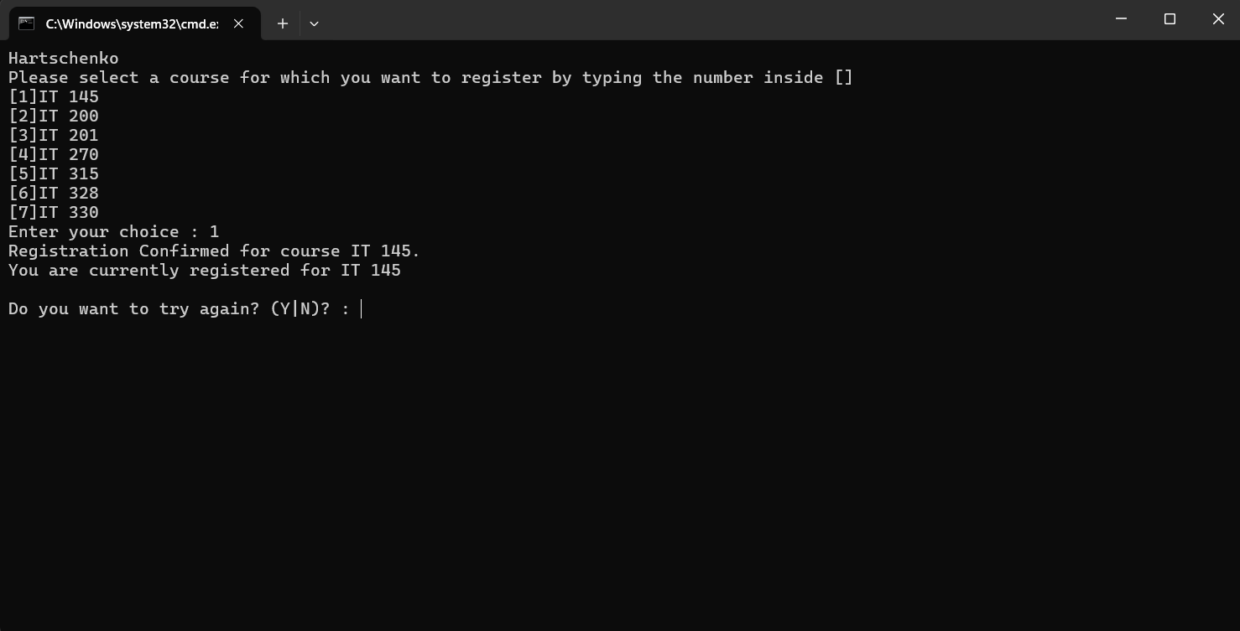

This screenshots hows that the user entered “1”. As a result, the program displays that the user is registered for the course that corresponds with 1 in the menu. Following this is a statement telling the user which courses they are registered for, which so far is just the one. Finally, at the bottom is a prompt asking the user to try again and waiting for a “y” or “n” response.

Screenshot 3.

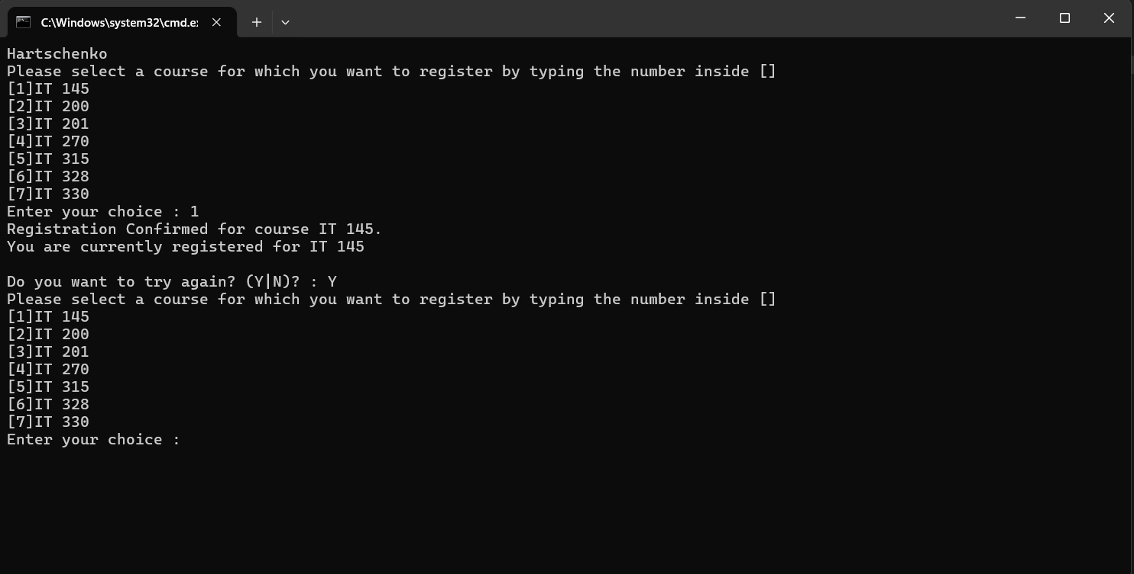

This screen appears after the user enters “y” after being prompted is they want to try again. After choosing “y”, the menu and its options are displayed again, the same way it was after initially running the program. Again, there is a prompt at the bottom asking for the user’s menu selection.

Screenshot 4.

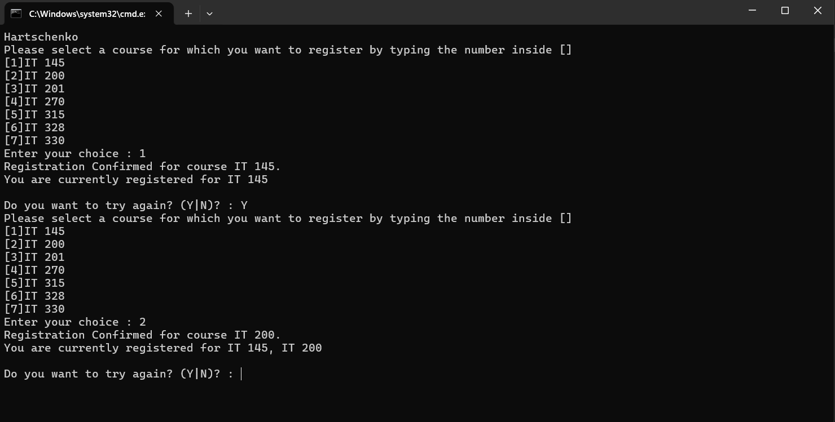

This screen is very similar to Screenshot 2. This screen is after the user has now entered the number “2” for their menu selection. Again, there is a statement telling the user of successful registration to the corresponding course followed by a list of the currently registered courses. Both courses are now displayed as the user has registered for two courses. At the bottom us the same prompt again asking the user if they want to try again.

Screenshot 5.

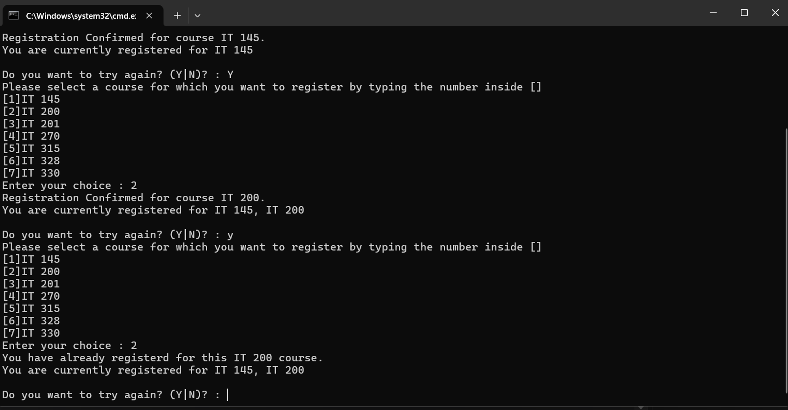

This screen shows that the user has entered “2” again after already registering for that course. The program handles this by telling the user they have already registered for that course, with the corresponding course title, and then prints the same statement below with the list of currently registered courses. The program then prompts the user again if they want to try again.

Screenshot 6.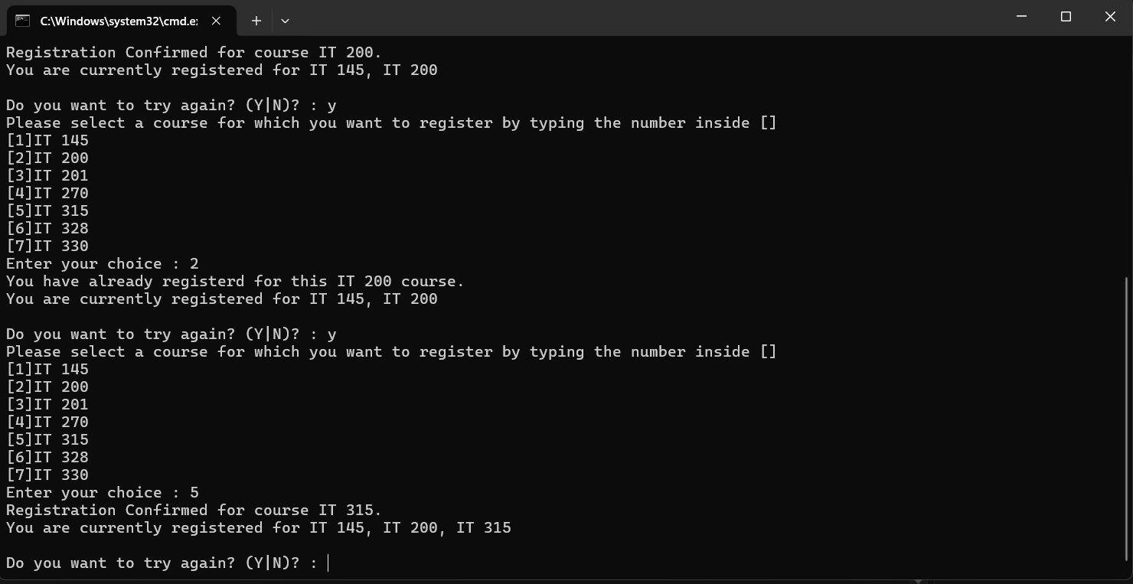

This screen shows that the user has entered “y” after handeling entered a selection they were already registered for. After seeing the menu and its options displayed again, the user then enters “5” to select that course. The program tells the user they has registered for that corresponding course and then dispalys all the courses the user has registered for. Now, the user has registered for thee courses. The program then prompts the user again if they want to try again.

Screenshot 7.

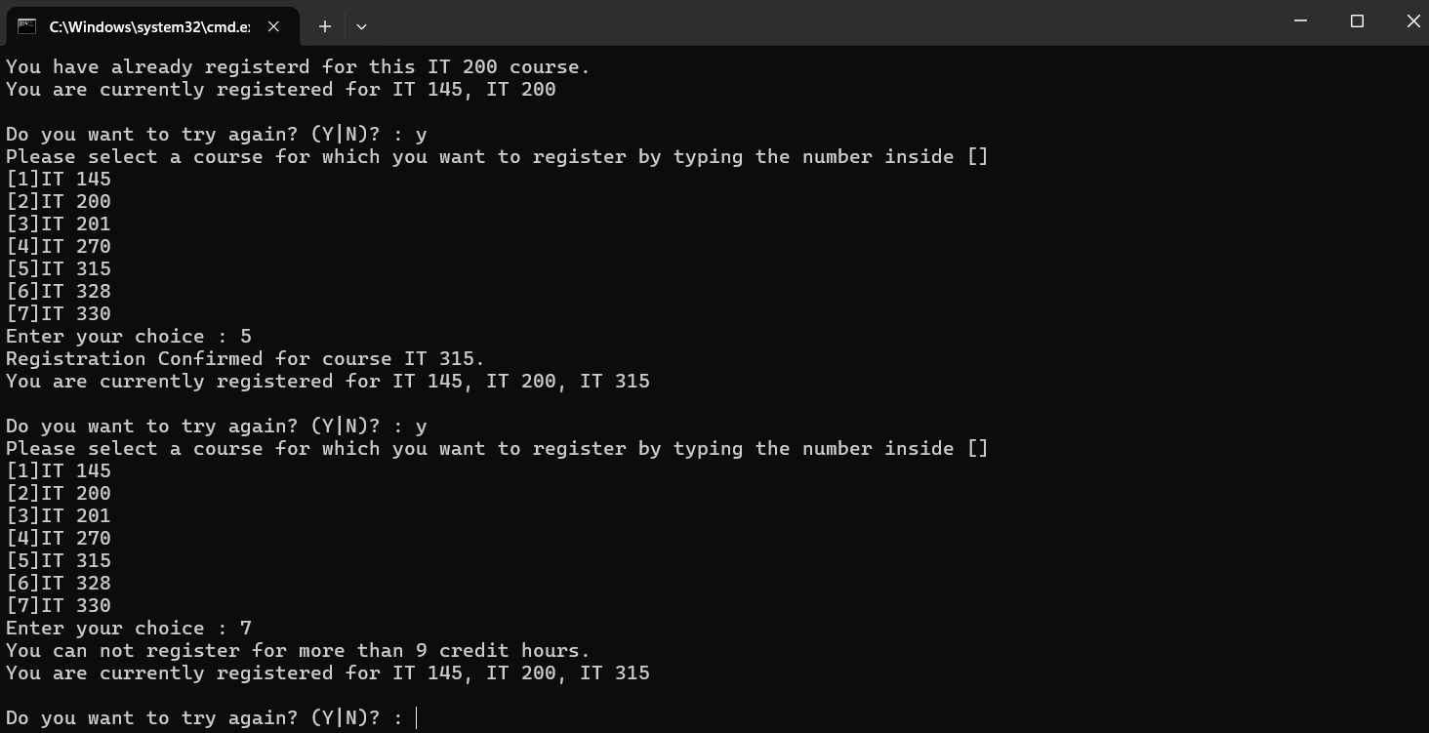

This screen shows that the user has entered “y” to try again and is trying to register for an additional course. Each course is three credit hours and the user can register for nine credit hours. Since the user has registered for three courses already, they should not be allowed to register for another course. The user enters “7” where prompted to attempt to register for that course. However, the program handles this by telling the user that they cannot register for more than nine credit hours and then displays the list of currently registered courses below. The program then prompts the user again if they want to try again.

Screenshot 8.

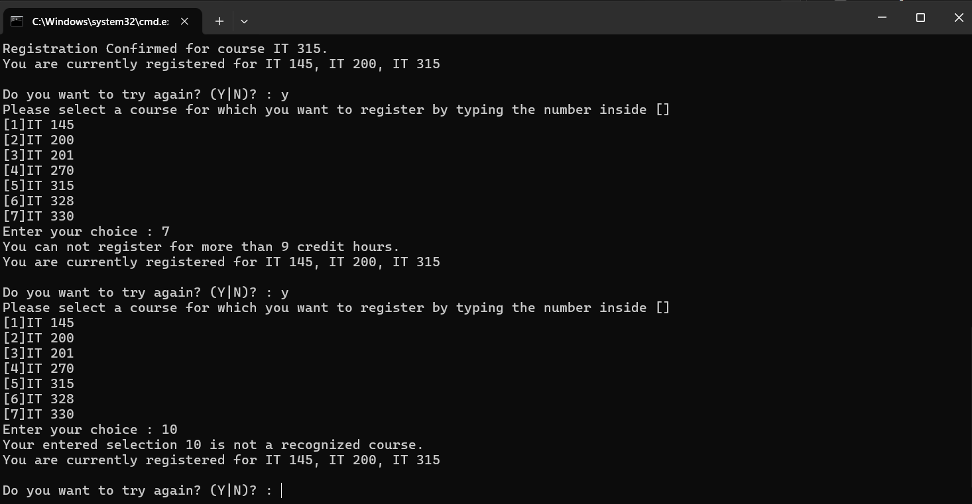

After entereing “y” when prompted to try again, the menu and its items are displayed again and the program awaits the user’s selection. The user enters “10”, which is not a menu option. The program handles this by telling the user that their selection is not a recognized course and displays the list of currently registered courses below. The program then asks the user if they want to try again and waits for a response.

Screenshot 9.

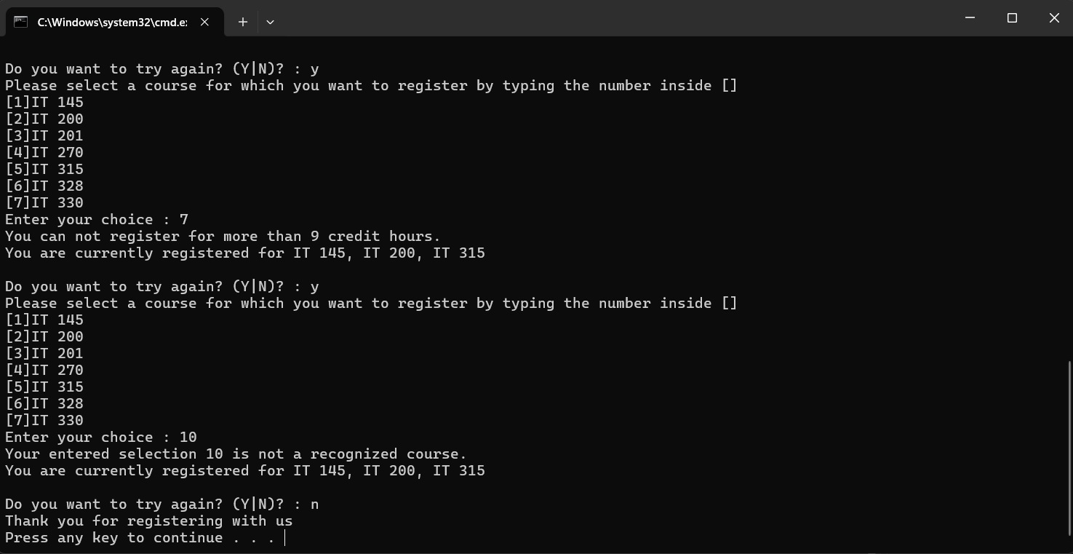

This program only terminates when the user enters “n” when prompted if they want to try again. This screen shows that action. After the user attempted to enter a course that was not on the menu and was subsequently prompted if they want to try again, the user entered “n”. This reponse ends the program and a simple thank you message is printed to the user and the program is now ready to terminate.

**Source Code**

/*

* Alexander Hartschenko

* November 26, 2024

* 5-2 Final Project Part I

*

* This program allows the user to enter an integer selection from a menu to register for an IT course.

* The user can register for up to 3 courses (9 credit hours).

* I debugged this code. All fixes are marked with in-line comments and all comments were made by me.

*/

using System;

using System.Collections.Generic;

using System.Linq;

using System.Text;

using System.Threading.Tasks;

namespace ConsoleRegisterStudent

{

class Program

{

static void Main(string[] args)

{

(new Program()).run();

}

void run()

{

int choice;

int firstChoice = 0, secondChoice = 0, thirdChoice = 0;

int totalCredit = 0;

string yesOrNo = "";

System.Console.WriteLine("Hartschenko"); // Changed to my name

do

{

WritePrompt();

choice = Convert.ToInt32(Console.ReadLine());

switch (ValidateChoice(choice, firstChoice, secondChoice, thirdChoice, totalCredit))

{

case -1:

Console.WriteLine("Your entered selection {0} is not a recognized course.", choice);

break;

case -2:

Console.WriteLine("You have already registerd for this {0} course.", ChoiceToCourse(choice));

break;

case -3:

Console.WriteLine("You can not register for more than 9 credit hours.");

break;

case 0:

Console.WriteLine("Registration Confirmed for course {0}.", ChoiceToCourse(choice));

totalCredit += 3;

if (firstChoice == 0)

firstChoice = choice;

else if (secondChoice == 0)

secondChoice = choice;

else if (thirdChoice == 0)

thirdChoice = choice;

break;

}

WriteCurrentRegistration(firstChoice, secondChoice, thirdChoice);

Console.Write("\nDo you want to try again? (Y|N)? : ");

yesOrNo = (Console.ReadLine()).ToUpper();

} while (yesOrNo == "Y");

Console.WriteLine("Thank you for registering with us");

}

void WritePrompt()

{

Console.WriteLine("Please select a course for which you want to register by typing the number inside []");

Console.WriteLine("[1]IT 145\n[2]IT 200\n[3]IT 201\n[4]IT 270\n[5]IT 315\n[6]IT 328\n[7]IT 330");

Console.Write("Enter your choice : ");

}

int ValidateChoice(int choice, int firstChoice, int secondChoice, int thirdChoice, int totalCredit)

{

/*

* Hartschenko

* 2024

* I have made a series of changes within this method. All changes are marked with a comment of what was altered.

* All changes commented were made by me

*/

if (choice < 1 || choice > 7) // I changed the second comparison, was initially 70 instead of 7

return -1;

else if ((choice == firstChoice) || (choice == secondChoice) || (choice == thirdChoice))

// I changed &&s to ||s and added parenthases

return -2;

else if (totalCredit >= 9) // Changed to also compare if is equal to 9

return -3;

return 0; // Changed to 0 (was set to return -4)

}

void WriteCurrentRegistration(int firstChoice, int secondChoice, int thirdChoice)

{

if (secondChoice == 0)

Console.WriteLine("You are currently registered for {0}", ChoiceToCourse(firstChoice));

else if (thirdChoice == 0)

Console.WriteLine("You are currently registered for {0}, {1}", ChoiceToCourse(firstChoice), ChoiceToCourse(secondChoice));

else

Console.WriteLine("You are currently registered for {0}, {1}, {2}", ChoiceToCourse(firstChoice), ChoiceToCourse(secondChoice), ChoiceToCourse(thirdChoice));

}

string ChoiceToCourse(int choice)

{

string course = "";

switch (choice)

{

case 1:

course = "IT 145";

break;

case 2:

course = "IT 200";

break;

case 3:

course = "IT 201";

break;

case 4:

course = "IT 270";

break;

case 5:

course = "IT 315";

break;

case 6:

course = "IT 328";

break;

case 7:

course = "IT 330";

break;

default:

break;

}

return course;

}

}

}